DHCP CONFIGURATION

Q1. In Cisco Packet Tracer, set up a simple network with one DHCP server and two client PCs. Configure the DHCP server to assign IP addresses automatically, then verify on each PC that it receives a different IP address from the DHCP pool.
Ans. I have created a topology in which I have created a DHCP pool through which the devices which are connected can get IP Address through Server Waya DHCP services
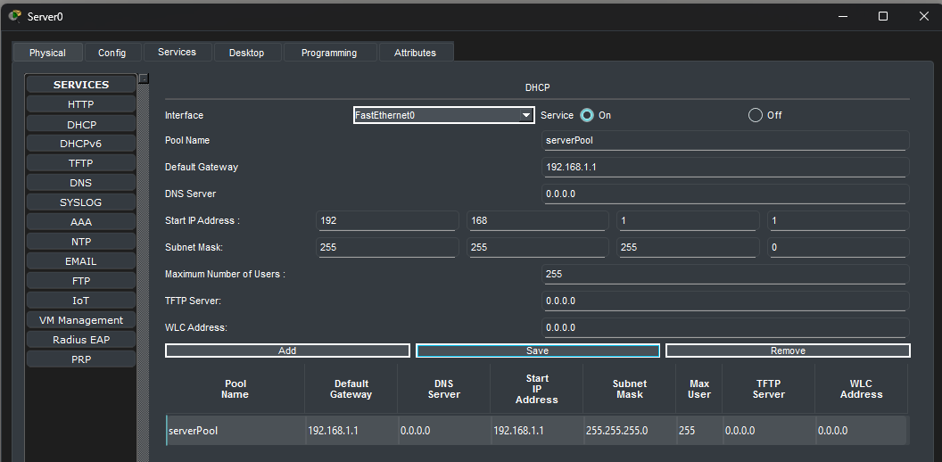
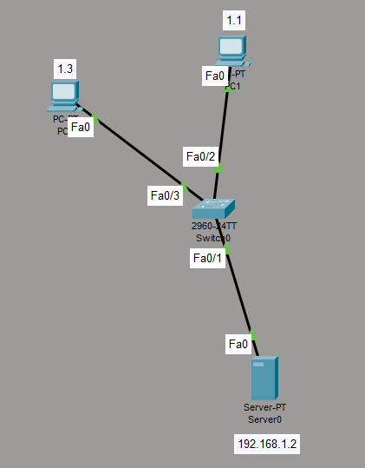
Q2. Draw a sequence diagram (hand-drawn or digital) that clearly shows each step of the DHCP process: Discover, Offer, Request, and Acknowledge, labelling the sender and receiver at each stage. Hint: Use arrows to show the direction of each message between client and server.
Ans.
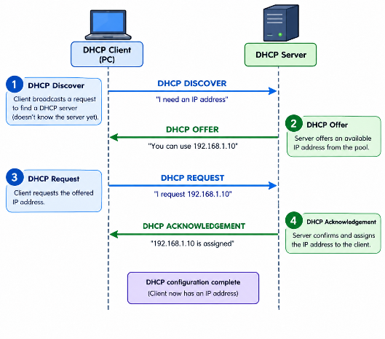

Q3. Change the DHCP pool range on your Cisco Packet Tracer DHCP server so that only one IP address is available. Add two PCs and observe what happens when both try to get an IP address. Take a screenshot of the result and explain in 2-3 lines why only one PC succeeds.
Ans. Only one IP address (192.168.1.10) is available in the DHCP pool. The first PC to request an address receives it, leaving no available IP address for the second PC, so its DHCP request fails.
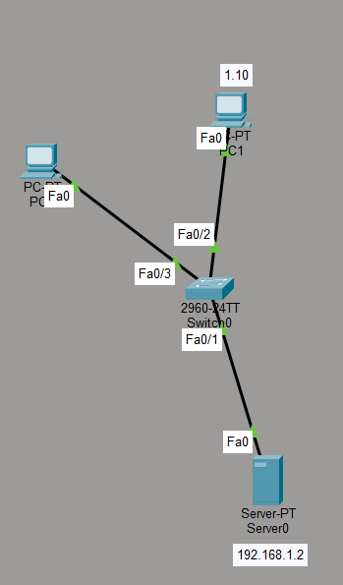
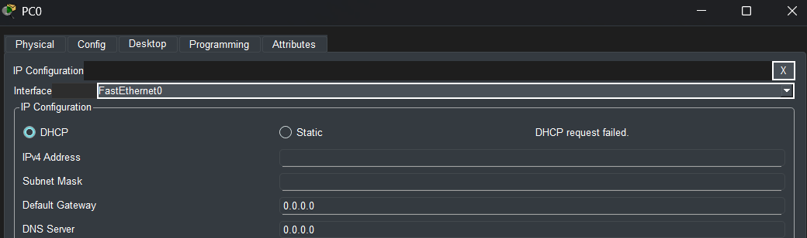
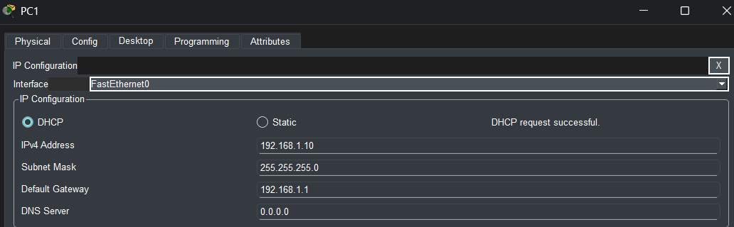
Q4. Simulate a Zomato-style restaurant Wi-Fi scenario in Cisco Packet Tracer: configure a DHCP server to provide IP addresses to both a laptop and a smartphone (use a generic PC as smartphone). Show the assigned IPs and explain why DHCP is useful in this situation.
Ans. Zomato-Style Restaurant Wi-Fi Using DHCP
Objective: - To create a restaurant Wi-Fi network where DHCP automatically assigns IP addresses to a laptop and smartphone.
Devices
- 1 Server (DHCP)
- 1 Access Point
- 1 Laptop
- 1 Generic PC (Smartphone)
Steps
1. Create the topology
DHCP Server → Access Point → Laptop + PC
2. Configure Server
Go to Server → Desktop → IP Configuration:
IP Address: 192.168.10.2
Subnet Mask: 255.255.255.0
3. Enable DHCP
Go to Server → Services → DHCP → ON.
Set: Start IP: 192.168.10.100
Subnet Mask: 255.255.255.0
Maximum Users: 50
Click Add.
4. Connect Server to Access Point
Use a Copper Straight-Through cable:
Server Fa0 → Access Point Fa0
5. Configure Wi-Fi
Set the Access Point SSID to: Zomato_WiFi
6. Connect the devices
Connect both the Laptop and Generic PC to Zomato_WiFi.
Go to Desktop → IP Configuration → DHCP on both devices.
Example:
- Laptop → 192.168.10.100
- Smartphone → 192.168.10.101
Why DHCP is Useful
- DHCP automatically assigns IP addresses, making it easy for many restaurant customers to connect without manually configuring their devices.
Result: - Both the laptop and smartphone successfully received IP addresses automatically from the DHCP server.

